#
# 20200806
#
https://wiki.tcsbank.ru/pages/viewpage.action?pageId=463544485
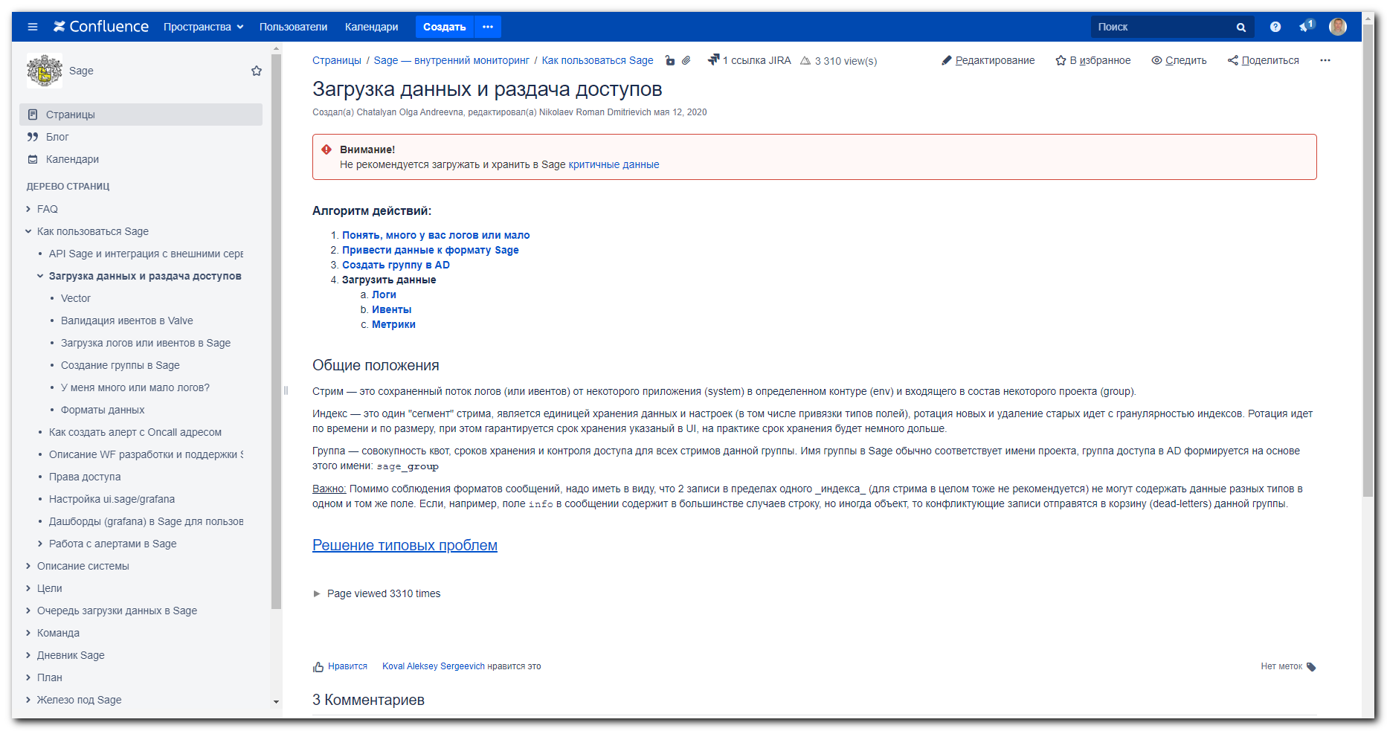

#
# 20200811
#
https://ui.sage/search
